新寮瀑布&謝師傅上菜&旺山南瓜園一日遊

出發日期:107年11月02日
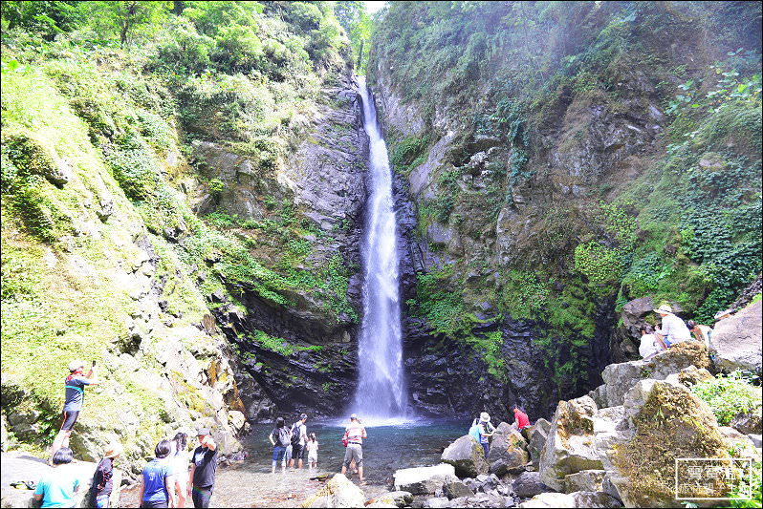
集合出發→新寮瀑布→謝師傅上菜→旺山休閒農場→奕順軒→回可愛的家
0700…快樂集合出發~國道風光~車上卡拉~影片觀賞
0810~0825石碇休息站~國道5號高速公路(雪山隧道)
0930~1130新寮瀑布(等了9年，宜蘭冬山「新寮瀑布步道」
從2018.07.04起重新對外開放，新寮瀑布步道全長1.5公里，沿
途漫步於溪畔邊可聆聽蟲鳴鳥叫、瀑聲轟隆、溪水潺潺更是蛙類
的天堂，動植物資源豐富完整展現台灣低海拔森林的樣貌。在秋
高氣爽的季節，邀請旅客走進新寮瀑布步道，享受瀑布邊的天然
負離子然芬多精，漫步賞景森呼吸)
1210~1400謝師傅上菜無菜單料理午餐(以養身、環保、時尚的菜系理念，融合節能
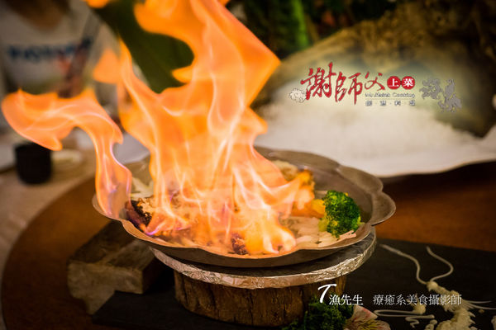
減碳與順著食材里程的取用原則，加上冰雕、花藝的精緻美學，完
美呈現平價時尚的美食饗宴。精湛廚藝、獨特新穎的烹煮手法，在
資深師傅創意揮灑下，讓飲食不單是飲食，而是「環保時尚」與「
養身藝術」的完美結合，吹起飲食文化另一波傳奇風潮。)
1430~1630旺山休閒農場--南瓜園(歷經十餘年的努力，旺山家族在觀光休閒領域，合
力打造一片南瓜園地。千奇百怪的大小南瓜，有吃的，也有專供賞玩的。每逢瓜果產季，慕
名而至的遊客絡繹不絕，成為蘭陽平原重要休閒景點。園區有專人導覽+南瓜披薩DIY還有好
喝的南瓜豆奶可以喝喔)
1700~1730礁溪.奕順軒(採購名產.奶凍捲.桂圓蛋糕…)
1740~1900回可愛的家。
~~~~~~~~~~~~~~~~~~~~~~~~~~~~~~~~~~~~~~~~~~~~~~~~~~~~~~~~~~
估價: 車 資：$13,000元/部(包含司機.小姐服務費、過路停車費、含5%稅金)
小 計：$13,000元/40人 每人：325元
＊＊＊＊＊＊＊＊＊＊＊＊＊＊＊＊＊＊＊＊＊＊＊＊＊＊＊＊＊＊＊＊＊＊＊＊＊＊＊＊＊＊＊＊＊＊＊＊＊＊＊＊＊＊＊＊＊＊＊＊＊＊＊＊＊＊＊＊＊
保 險：觀光局履約保險200萬意外險含20萬醫療險每人：55元
＊＊＊＊＊＊＊＊＊＊＊＊＊＊＊＊＊＊＊＊＊＊＊＊＊＊＊＊＊＊＊＊＊＊＊＊＊＊＊＊＊＊＊＊＊＊＊＊＊＊＊＊＊＊＊＊＊＊＊＊＊＊＊＊＊＊＊＊＊
餐 食：午餐$660元(600+10%服務費) 每人：660元
(以上不含白飯及飲料費用，茶類每瓶60元.果汁類每瓶80元，餐廳有提供熱茶)
＊＊＊＊＊＊＊＊＊＊＊＊＊＊＊＊＊＊＊＊＊＊＊＊＊＊＊＊＊＊＊＊＊＊＊＊＊＊＊＊＊＊＊＊＊＊＊＊＊＊＊＊＊＊＊＊＊＊＊＊＊＊＊＊＊＊＊＊＊
門 票：旺山休閒農場(披薩DIY+導覽+豆奶)$250元/人每人：250元
＊＊＊＊＊＊＊＊＊＊＊＊＊＊＊＊＊＊＊＊＊＊＊＊＊＊＊＊＊＊＊＊＊＊＊＊＊＊＊＊＊＊＊＊＊＊＊＊＊＊＊＊＊＊＊＊＊＊＊＊＊＊＊＊＊＊＊＊＊
以上每人團費合計: $1290元/人

